

Dear friends of UB Global,

Despite some challenges this year, we praise God for the incredible fruit from 2023!
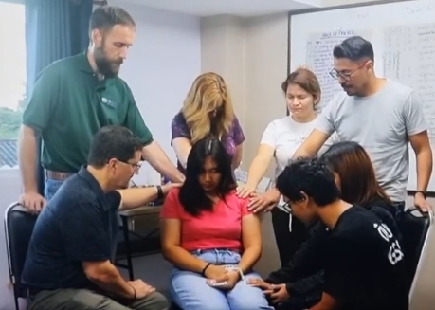
Unreached Thais trusting Jesus
For over a year now, the Thailand team has been visiting Grandfather Moi as a part of their weekly home visits around the neighborhood. One day this summer, he shared with the team that he is praying in the name of Jesus and has chosen to follow Jesus! We were all overjoyed because this dear old man is now our brother in Christ. Then this fall, Miew, his grandson’s wife, also decided to become a Christian! (Our missionary from Honduras has been investing in Miew for several years.) This is exciting because on average, it takes 6 years for a Northern Thai (who are half of 1% Christian) to put their faith in Jesus. Let’s keep praying for new believers and local friends on UB mission fields whose hearts are ever softening toward their true King.

Successful National Conference
Our team put tremendous effort toward National Conference in Fort Wayne this summer. We facilitated the majority of an evening service, led six workshops, initiated a new international experience drawing in over 40 people, created a whole new escape room which had over 100 participants, made new videos, missions materials, and more. It took an incredible amount of work. But it was worth it! We connected with new friends, strengthened relationships, and cast the vision of UB missions. If you’re interested in watching the service, go to ubGlobal.org/NC23

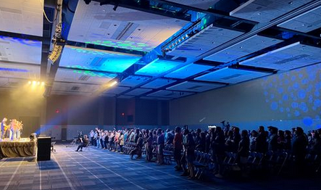
New Missionaries
Since conference, there have been 9 adults and 6 young people who have either applied for missionary service with us or are seriously exploring how the Lord may be calling them. Nearly all of them are considering missions among unreached people groups like the tribal Muslim Shoptar (ubGlobal.org/Shoptar) or Northern Thai (ubGlobal.org/Thailand). We’ve also recently accepted a young lady who will be serving a people who are a part of a highly repressive regime we often hear about on the news. We praise God for all these possible new missionaries!
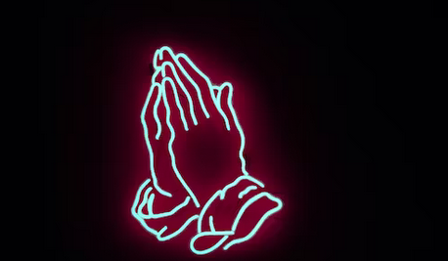
Impactful Prayer Network
It’s no coincidence that since initiating and fostering a UB Global grassroots prayer network a year ago, we are seeing answers to prayer on mission fields and these new missionaries (for which we regularly ask). Five people faithfully lead believers from around the country in praying every month online. We are grateful for these volunteer leaders and the monthly prayer warriors! (ubGlobal.org/PrayerNetwork)

Sharing about missions
This year, our team of five shared inspirationally in 40 different settings, the majority in churches on Sunday mornings. We’re grateful for many opportunities to connect with fellow believers, whether it’s with a small group of twelve or an auditorium of 700 students.
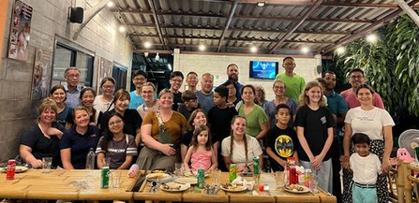
Short-term Missions Trips
We facilitated & sent five short-term mission teams to the Middle East and Asia. We anticipate six in 2024, including to places like Germany, the Middle East, Thailand, and large cities in N. America. These trips allow teams to help the long-term team serve unreached people groups while growing the go-ers’ passion for Jesus & vision for missions. (ubGlobal.org/Trips)

Celebrate!
Last year, we held a regional family-friendly missions event called Celebrate. It brought over 175 believers together in northeast Indiana to learn & network together, and inspirationally learn & engage in what God is doing around the world. In 2024, we will gather with churches in Michigan (January) and Pennsylvania (April) for Celebrate events. We look forward to great connections to missions in our neighborhoods and into the nations. (ubGlobal.org/Celebrate)

Thank you for your faithful prayers, advocacy, and generosity. Missions belongs to the whole church, and we are grateful that we can partner with you.

Your UB Global Team,

Courtney Waterman
David Kline
Frank Yang
Steve Fish
Teresa Roberts

