

July-September 2023
Hello Pastors and Friends,
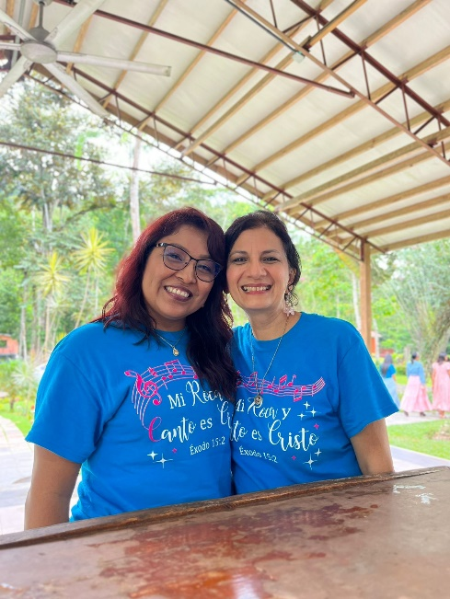
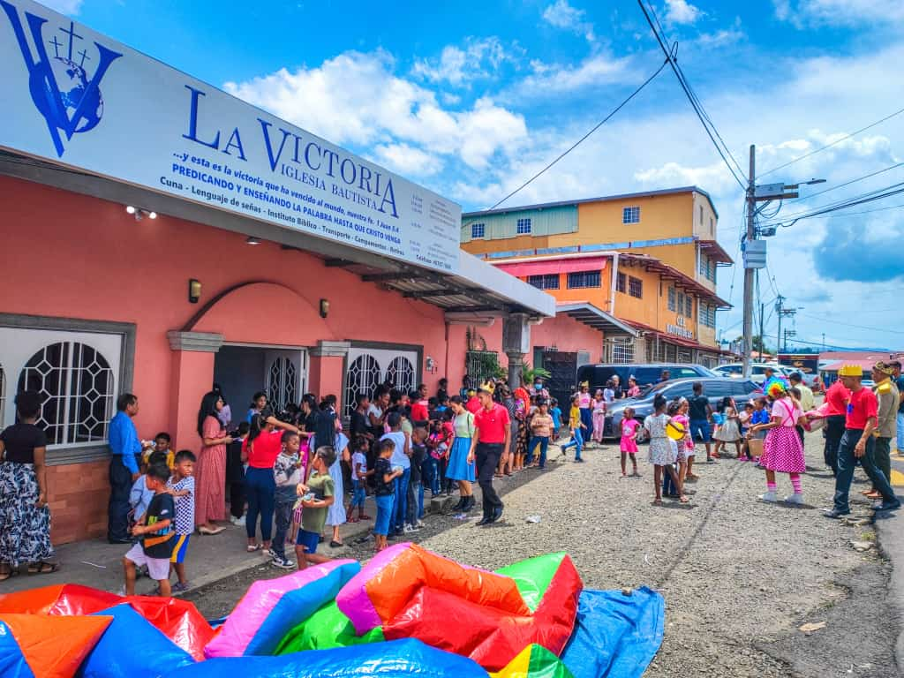

We trust you are having an outstanding day with the Lord! Having got Mother’s Day and Father’s Day behind us, as well as Elizabeth’s, Brenda’s and my own birthday. We celebrated the Day of the Child, on the 23rd of July. As always it was a tremendous success! In Victory Baptist Church God gave us more than one hundred and fifty-three children! At least 9 adult visitors, with four adults and ten children making professions of faith in Christ Praise the Lord!
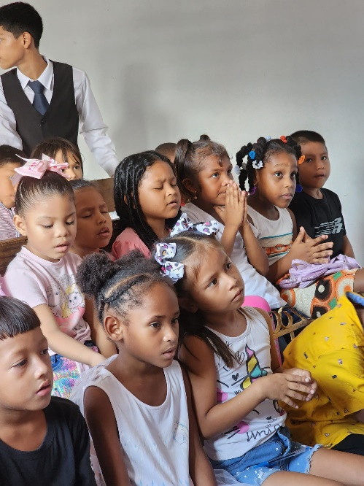
The Lord was not finished with us yet! In the evening, at Trinity Baptist Church God once again abundantly blessed! Making three trips with our 15-passenger van, I picked up probably seventy or more riders! I couldn’t have put another child in the van, it was so packed! We ended up having a total attendance of 102 (49 Adults and 53 kids) as well as 5 visitors!
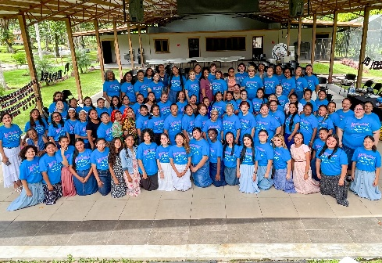
September is officially the month of the Bible here in Panama as well as in our church. Every year we purchase a lot of nice Bibles for all ages and really make a big deal of the month-long competition! Members gain points for reading their Bibles daily, praying, attending services, soulwinning, bringing visitors, and of course, memorizing Bible verses! The very things a mature Christian should already be doing! We motivate them to establish these good habits in their daily lives! We even had the Bible bookstores workers want to come to church to participate in the opportunity of winning these fantastic gifts!
Our annual ladies retreat just ended a few days ago with an attendance of 90 ladies representing 14 churches in the country. Missionary wife in Panama, Rossy de Robles, was the main speaker. The Lord really blessed with a refreshing, rested, and blessed time!!

Lord willing, we are planning a short three-month FURLOUGH for April-June 2024. Please let us know if you would be interested in us scheduling a meeting and giving you an update of what the Lord is doing in your ministry here in Panama!
We are definitely very grateful to our Father for all the years He has given us to serve Him in Panama! We are still waiting for the permits to be able to build the building for the Iglesia Bautista Trinidad. We already have 45% of the finances needed to build the first phase and we continue to pray for the rest. God is faithful! Thank you again for your support and prayers!

Because of Christ and Souls,
The Booth Family, Ro.8:32

