**ABOUT DELTAWEST SERVICE ASSOCIATION (DWSA):**

DeltaWest Service Association (DWSA) came into existence towards the end of the year 2017 with the sole aim to uplift the poor in the surrounding communities and to give them hope and dignity by providing services in health, education and skill development, child care and terminal care.



*“Poverty robs people of dignity, freedom and hope of power on their own lives. Our vision is to take up such activities to uplift the poor and give them hope”.*

**AIMS & OBJECTIVES:**

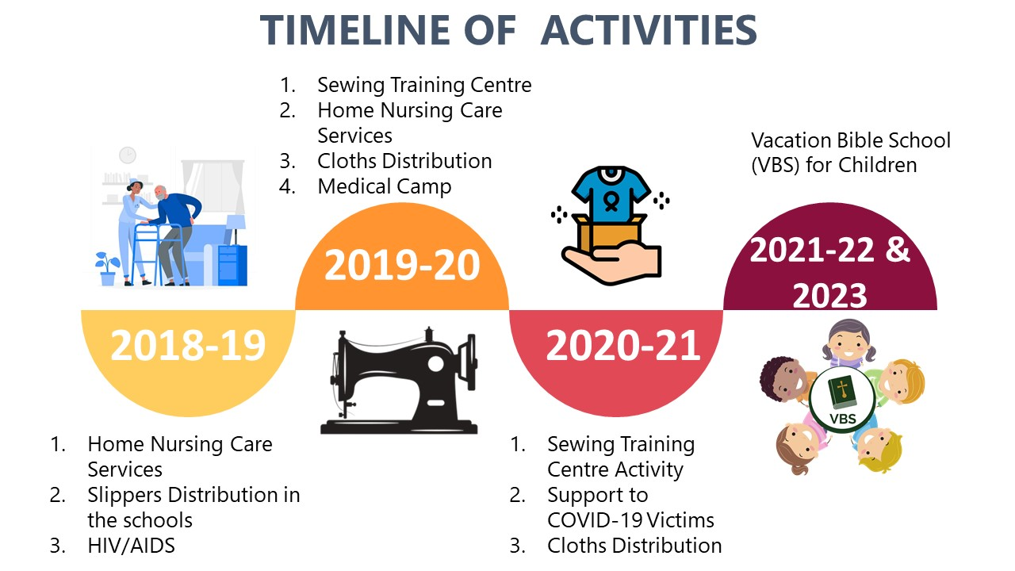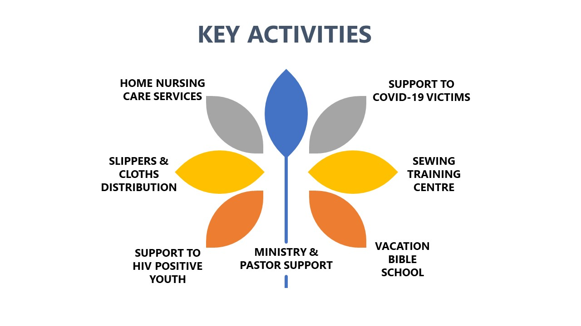

1. MINISTRY & PASTOR SUPPORT

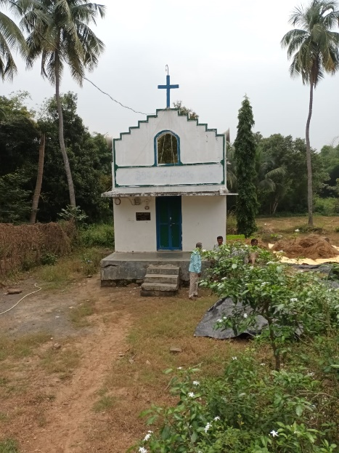Srikakulam District in Andhra Pradesh is one of the backward districts. Living in the foot hills of Eastern Ghats are many tribal groups who live away from the civilization. Having a burden for their souls, one man of God called by the Lord went to that area. With much prayer he proclaimed the good news of salvation to them and won a few for the Lord. With such small beginning, the Lord blessed the ministry. Some of the believers took the gospel to different villages and won souls for the Lord. About 14 churches were established in the remote areas of the district and hundreds of saved souls were added. The Lord blessed this ministry in a wonderful way. In order to provide a roof for the believers to meet and worship the Lord, small church buildings were constructed in these places. The servants of God working in these villages are supported by DeltaWest Service Association by praying for them and meeting their financial needs. Members from DWSA visit these places now and then to encourage and to have fellowship with the pastors working there and with the believers.

1. HOME NURSING CARE SERVICES

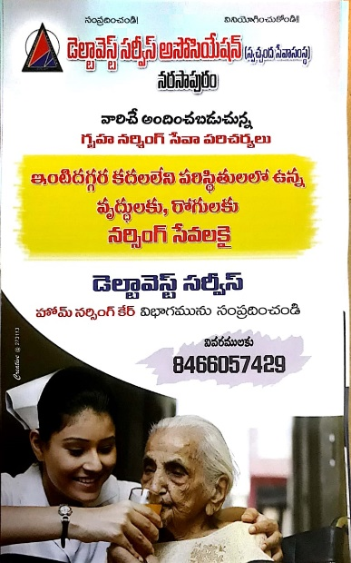This activity is aimed at providing home care nursing services to bed ridden patients and old people who can not avail simple services like blood pressure and sugar levels monitoring, dressing of wounds and palliative care to terminally ill patients.

A qualified Nurse with an assistant were provided with needed equipment and a van for transport. A telephone number was provided to this unit to call and seek assistance.

Pamphlet in Local Language (Telugu)

1. SLIPPERS & CLOTHS DISTRIBUTION

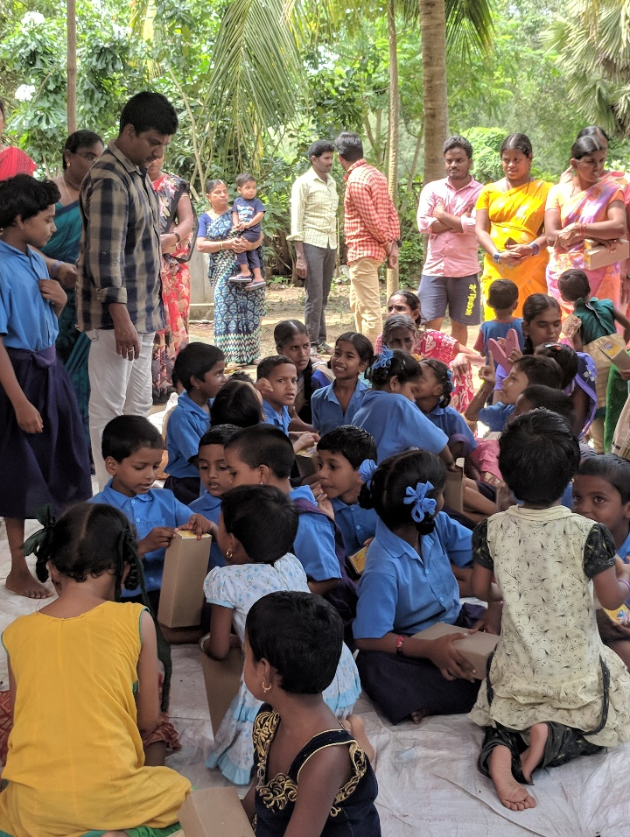Noticing that many of the rural children don’t wear any protection to their feet resulting in health problems such as worm infestations, we have chosen a few rural schools and with the help of the school teachers, distributed Hawaii slippers to all the children studying in the schools. It was well received and appreciated by the parents and teachers.

1. SUPPORT TO HIV POSITIVE YOUTH

Some of the boys and girls suffering from HIV/AIDS were in constant touch with the association. They were advised and counselled regularly and encouraged to continue treatment from government centres without fail. Most of them were orphaned young people. One of the girls, when she is marrying another HIV positive young man, she was helped financially to meet the wedding expenses.

1. SUPPORT TO COVID-19 VICTIMS

COVID-19 pandemic wrought havoc in the lives of people. Many lost their livelihood. Many people fell sick and so many families lost their loved ones. Fear gripped people’s minds and they could not venture out in search of work. Hence many poor families could not afford at least one meal a day. Governments came to their rescue by providing free rations.

Deltawest Service Association felt the obligation of providing something for the poor to sustain them during the pandemic. So around 200 families were helped with essential commodities like rice, dhal, cooking oil, sugar and others.

1. SEWING TRAINING CENTRE

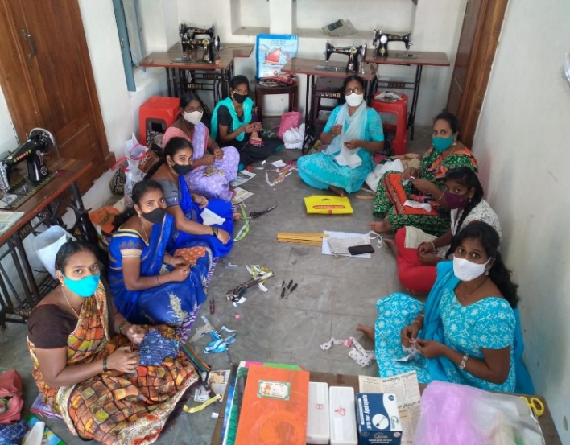Many of the women in poor households, stay back home because of the responsibilities at home, but many of them want to support their husbands in bearing the financial burden of the family in their spare time. Keeping this in mind, a tailoring training program was initiated during the year 2019. Sewing machines and needed materials were bought and a qualified instructor was appointed.

We had an overwhelming response to this training program, as the training was provided free of charge. The duration of this training was 3 months. Eleven batches of women were trained and the 12th batch is in progress.

1. VACATION BIBLE SCHOOL

To strengthen the ministry among children in the churches, Vacation Bible School was arranged for the last two years in the area with the help of Children Missionaries. Hundreds of children were taught choruses, Bible stories with the help of audio-visual aids, puppet shows and ventriloquy.

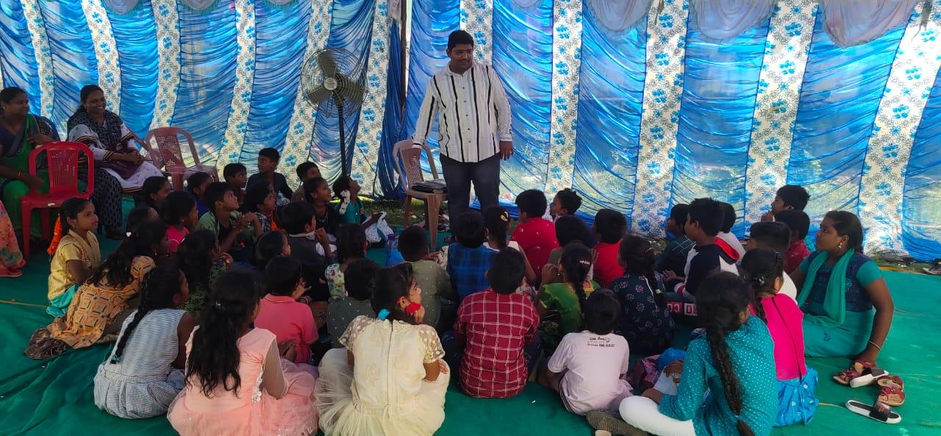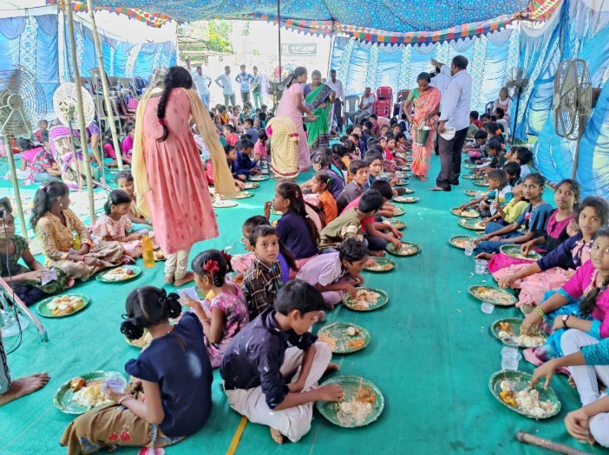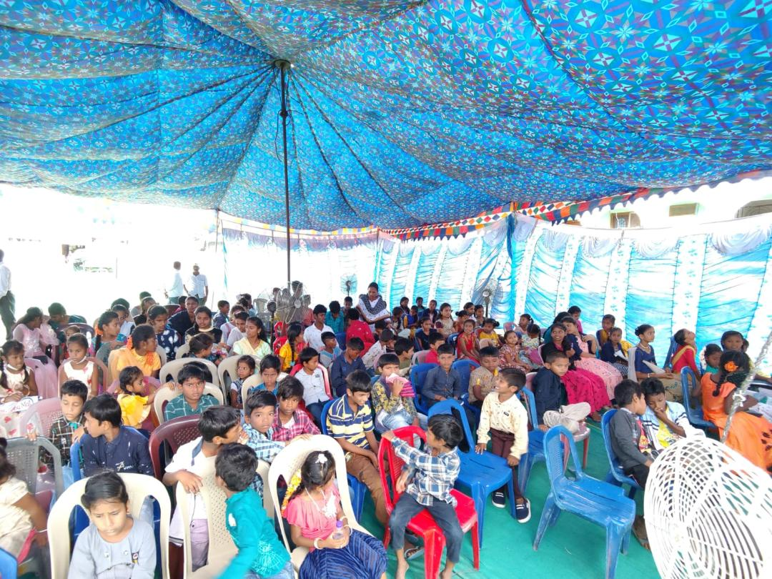They were provided with delicious lunch, and the children greatly enjoyed the fellowship. Transport arrangements were made to bring children to the venue. Seeds were sown in their tender hearts. Trusting and praying God in His own time will make them sprout and grow. God willing, DeltaWest Service Association is praying and planning to continue these support services to the ministry of the pastors.

**THANK YOU**