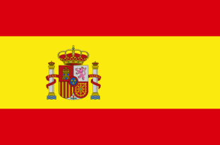The Torres family 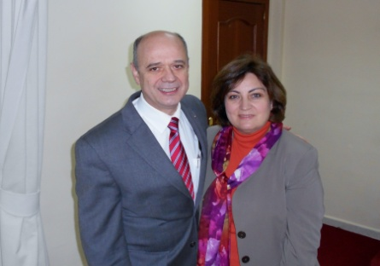

Missionaries in Spain

*Plaza de las Palmeras 13, 4 A. 28850 Torrejón de Ardoz, Madrid-ESPAÑA* [*pedrotoga@yahoo.es*](mailto:pedrotoga@yahoo.es) **January 2024**

Beloved Financial and Prayerful Supporters:

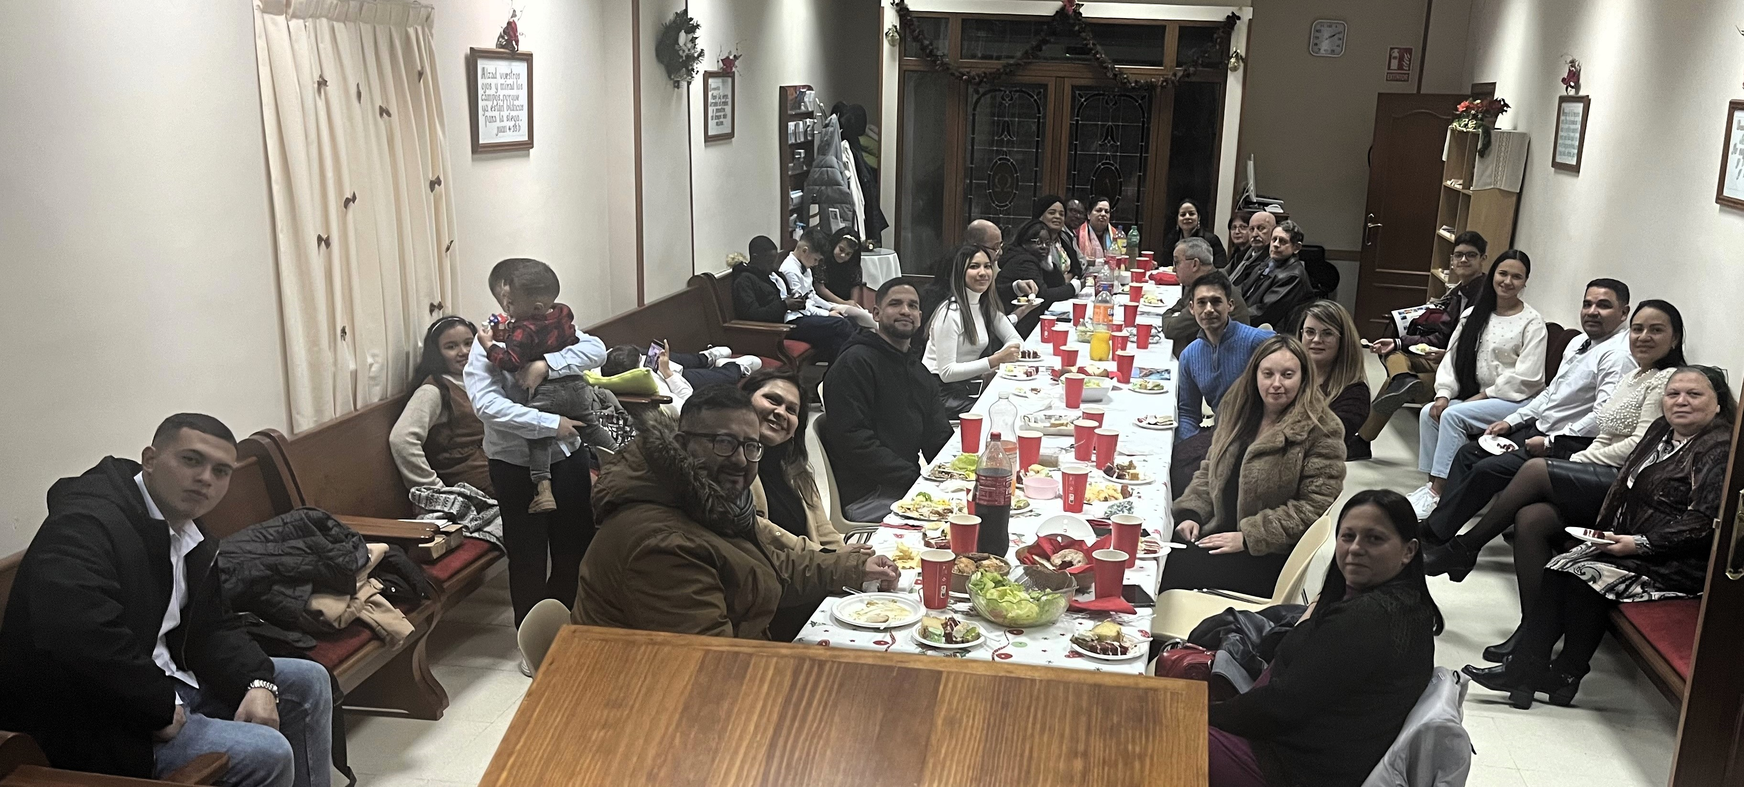We wish you the richest blessings of the Lord for this year that we begin. We thank God very much for your financial and prayerful support, we have been very blessed with the extra offerings and Christmas cards we have received. Thank you from the bottom of our hearts.

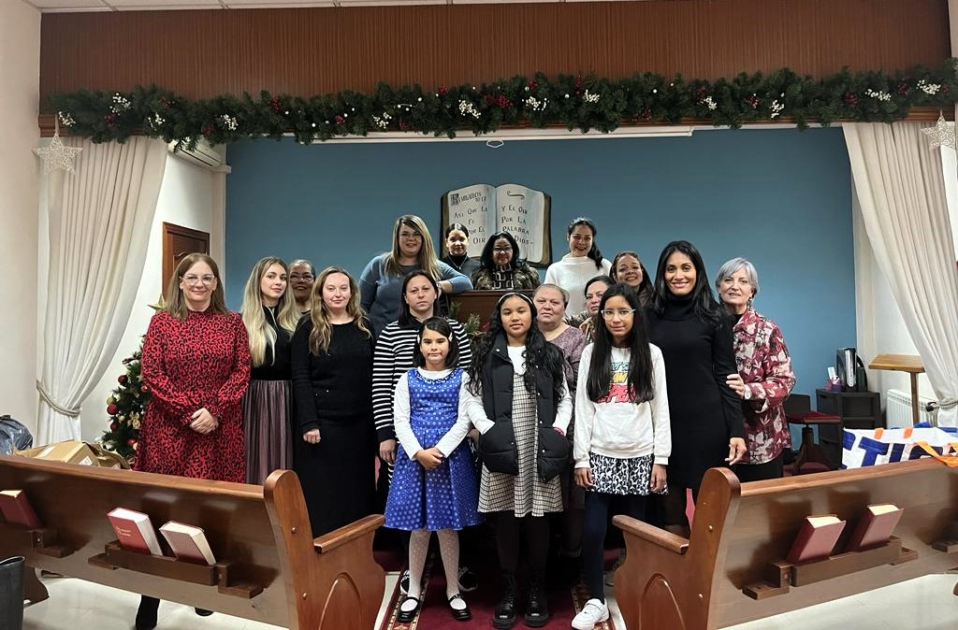 December has been a very busy month; we went out to distribute Christmas brochures with the plan of salvation, and we went to visit some relatives and friends of brothers of the Church presenting the Gospel to them.

We also had our Christmas Ladies' Meeting, very well attended, thank God.

On December 24, the Sunday school children presented their Christmas program, and we had a meal attended by visitors who were not believers, who heard a presentation of the Gospel.

The week of January 8th we will resume classes at the Bible Institute.

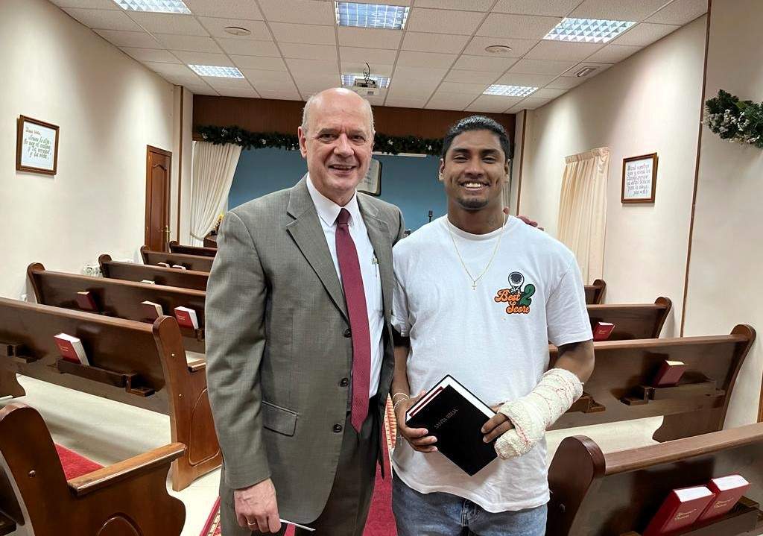 We ask you to pray for William, a young unconverted Colombian who has begun to attend church.

We are looking forward to have our Missionary Conference on February 3 and 4, with the missionary to Equatorial Guinea (Isaac Amaya). We ask for your prayers for these meetings.

*Prayer requests*: Salvation of Elvis, Yesimar, Mari Angeles, Pedro Vicente, Oreste, Mari y Carmina. That God sends us some like-minded workers. For Spain, for our rulers, and for God to protect us and keeps us faithful in these perilous times we are living in, and that God takes care of our young people and children.

In the Beloved,

Pedro and Charo

**Church (Stateside)** Madison Baptist Church Madison, AL 35758 Pastor: Dr. Mike Allison 840 Balch Road

**Sending Church**

Iglesia Bautista “El Faro”

Apdo. 1087

28805 Alcalá de Henares

(Madrid) España

**Mission Board**

Gospel Furthering Fellowship

221 Hamilton Ave.

Myerstown, PA 17067

Director: Rodney Myers