**News from the Smiths in South Africa**

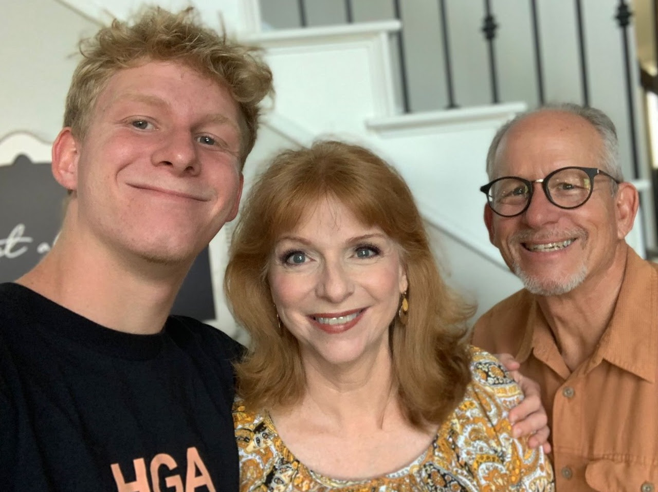

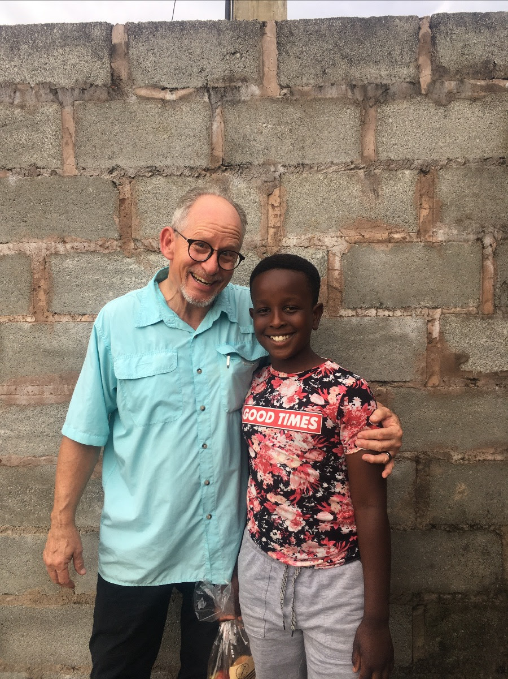

Dear Praying Friends,

Psalm 33:1 says "Rejoice in the LORD, O ye righteous: for praise is comely for

the upright." Verse 11 says "The counsel of the LORD standeth forever,

the thoughts of His Heart to all generations."

How we praise the Lord for His grace and faithfulness as we walk with Him on

the road of life God has called us to. It is good for all of us to make godly

plans, and taking the right steps will help to keep us on the right road with God

throughout the year. On the highway near us, there is a huge sign from a local

grocery store that says "We've got more in 2024!" It reminds me to "Give God

more in 2024!" More time, more talents, and more treasures to be used for His

kingdom service.

The end of last year was again a time to share the love of God in celebrating

His Incarnation, and the promises of God's Word fulfilled and forever true!

We praise God for the dear Zulu children recently saved in KwanDenGezi, and

our elderly Afrikaans neighbours who also came to Christ last year too.

The new year also brought 11 year old Mnunthi to a saving knowledge of Jesus

Christ! He has been with us over five years, and he has heard the Gospel every

week. What a joy it was to see Mnunthi respond to the Holy Spirit's conviction

and drawing him to believe in Christ alone for his salvation. We are discipling

him in his walk to grow in grace and serving Jesus. His happy attitude and

radically changed bad behaviour in just 3 weeks is a testimony to the great

transformation in his young life. Before his salvation, not a week went by that

he didn't pick a fight or cause disturbances during the message. We praise God

for this new child of the King, and we believe God has a great plan for his life.

We are planning a short furlough in the USA from May through September this

year. Our youngest son Josiah graduated from high school in December 2023,

and will be going to Bible college in August of this year in the states. We are

excited to see what God has ahead for him, but we will also greatly miss him

and especially the help he is at KwanDenGezi and Grace Baptist churches, and

helping with the youth at New Germany Baptist church too. We also need to

renew our missionary visas in the USA, which expire September 30, 2024. We

would love to visit as many of our supporters as possible during the few months

we will be in the states. Please contact us if you would like us to speak at your

church when we are back. You may email us at bclsmith@gmail.com or by

phone or WhatsApp at +27 074 936 3587.

We thank God for each one of you, and for your many prayers and faithful

support for God's mission field of South Africa. We appreciate your love and

care of us so very much!

Praising the Lord with you,

Brian & Cheri, and Josiah Smith

Psalm 16:11