**The Blanchard Family in Australia**

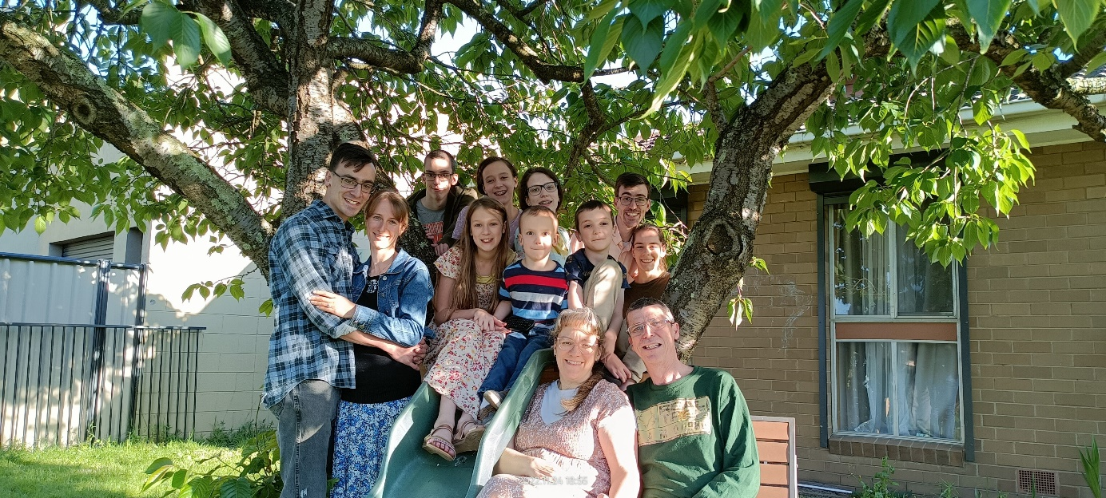

Monthly Newsletter

February 1, 2024

**Ministry News:**

The Work continues here in Moe Victoria, and God has been so good. Our radio program on the local secular station has now been moved to Sunday morning completely (no more Tuesdays) but we do have from 8 to 10 AM to preach the Bible and play Godly music. If you would like to listen, the programs are archived on 3bbrfm.org.au under the program name “Family Time at Calvary.” We’ve had several visitors lately and a few have started coming faithfully. The missions’ trip to the Philippines went well, we saw 5 people saved and 5 called to full time Christian service. The men of our church, including my sons Samuel and Luke, did an amazing job filling in in our absence. Our Bible Institute is beginning again in February on the 5th and we also plan to baptize on the 4th. We plan to redouble our soul winning especially in Sale to help bolster the work there.

**Family News**:

As I mentioned in the last prayerletter, my dad had a stroke in December and is doing pretty good, but please keep him in prayer. The family is well, and we are excited about just how God is working in each individual life, as well as in the family as a whole. Josiah is now doing an apprenticeship in mechanics with Luke, at Ford in Warragul. Sam and Taylah have been such a blessing, Taylah is now filling the role of church cleaner for us. Luke, Cherie and Anna are well also and I’m so thankful for all my children, as they all help in one way or another in the church here.

Other prayer requests for this month are: 1. Calvary Baptist Church of Moe2. The new work, Faith Baptist Church in Sale, Victoria.; 3. **That God would give us a camp, He owns it all!** 4. Brother Ron Back and his family, and their mission work in the prison in Sale, **Victoria.**5. Our weekly Radio Broadcasts on 3BBR, 103.1 FM.   
6. Continuing good health for myself and family, including my dad’s recovery**.** 7. Brother Babia and family in the Philippines.   
8. More souls to be saved, more workers and visitors.   
9. The Lord to call a man to Pastor one of the works here.   
We do feel the wonderful effects of your prayer and thank you all for remembering us.

New Support Address:

Northside Baptist Church,

P.O. Box 960, Burnet, Texas 78611  
 Pastor Jimmy Frazier

Field Address:

P.O Box 69, Moe, Victoria 3825, Australia

Ring us in Australia on **903 483 1961**

Australian Cell Number 01161418397279

blanchardprayerletter@gmail.com

www.northsidebc.net

All for Jesus,

The Blanchard Family

Russel, Terri, Josiah, Ruth, Lindsey, Katelyn, Jacob, and Peter

Sam and Taylah

Luke, Cherie and Anna

Psalm 108:13, 2 Tim 4:9 Phil 1:12

See our service at www.youtube.com/user/@cbcm

www.calvarycares.org.au