John & Ronda Lennon

Missionaries to Ecuador

**Please Do Not Share or Post on Social Media**

**February 2024**

Dear Friends & Family,

When you turn on the tv these days or scroll through the news feed on your phones, you will see that Iran is usually in the headlines as it relates to the war in the Middle East. The geopolitical aggression of the Islamic Republic of Iran and the oppression of its people have caused myriads of its citizens to migrate to other countries in search of freedom.

Monty** and his family came to Ecuador, and they became our next-door neighbors. He was very agnostic and skeptical about religion when we first met him. Throughout the next two and a half years, Monty asked lots of questions about Christianity and wrestled with the scriptural teachings of the Trinity, human suffering, and Christ’s substitutional atonement on the cross for our sins. After many meetings and countless questions, Monty trusted Jesus Christ as his Savior during a Bible study. Recently, Monty decided to follow the Lord in believer’s baptism. As with many people from Muslim countries, a decision to be baptized is an all-in decision just like the old hymn states, “I have decided to follow Jesus, no turning back, no turning back.”

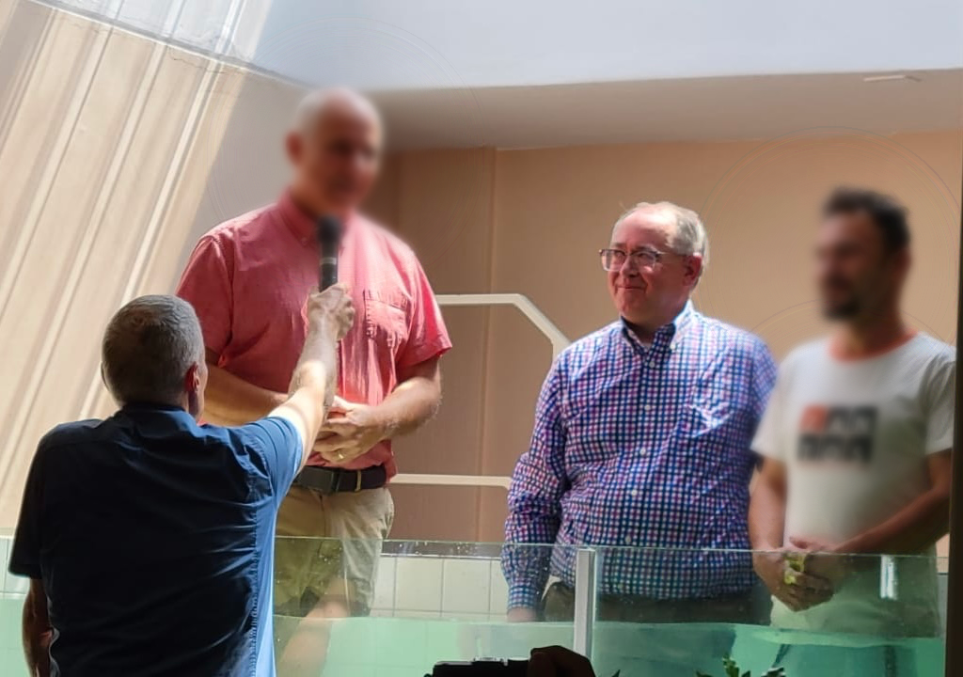

Believer’s baptism of a Persian man

**not real name

Monty and many other families have come to Ecuador in search of freedom and a better life. For whatever reason they have left their home country, we know that God has brought them to Ecuador to hear the Gospel. It is with this focus that we shared with you the Farsi language children’s Bible curriculum project in our last prayer letter. Because of your sacrificial giving, we were able to begin the translation of the 99 Adventures, The Bible’s Big Story by Dr. Jim Cook. At the time of the publishing of this prayer letter, the first section of the curriculum is almost complete. There is a seven-step process for which the translation team is using to translate this curriculum. Please be in prayer for God’s protection and wisdom for the translation team. One key team member was recently in a car accident and will be held up as he heals from his injuries.

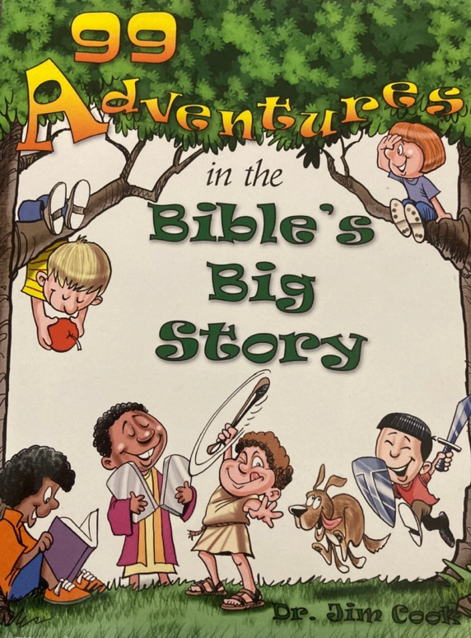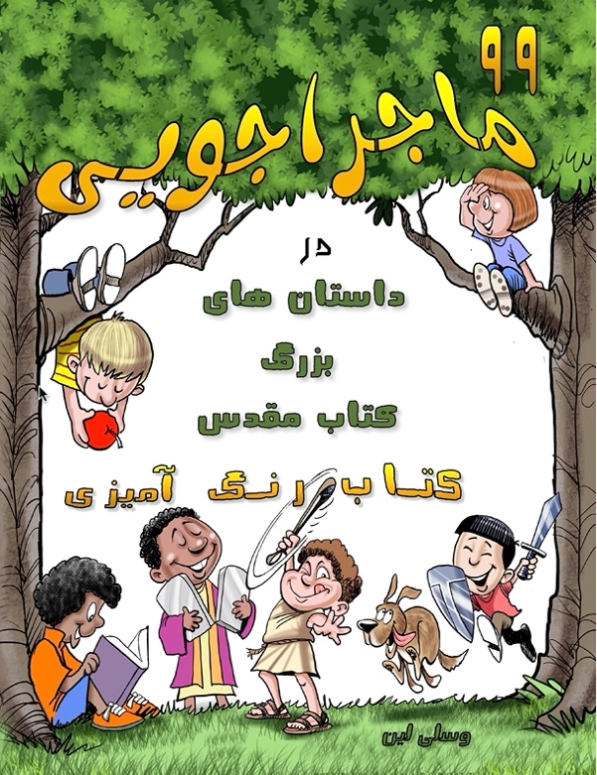

The translation of the children’s Bible curriculum has begun.

As you hear about the Islamic Republic of Iran in the news each day, please take advantage and pray for the salvation of the people in Iran and those Iranians who make Ecuador their home.

For the Sake of the Gospel,

John & Ronda Lennon

Quito, Ecuador



Mission: Daystar Baptist Mission, [www.dbmi.org/give](http://www.dbmi.org/give)

E-mail address: [j.lennon@dbmi.org](mailto:j.lennon@dbmi.org)

Mail: % 209 Daniel Way, Portsmouth, VA 23701

Sending Church: Central Baptist Church, Portsmouth, Virginia