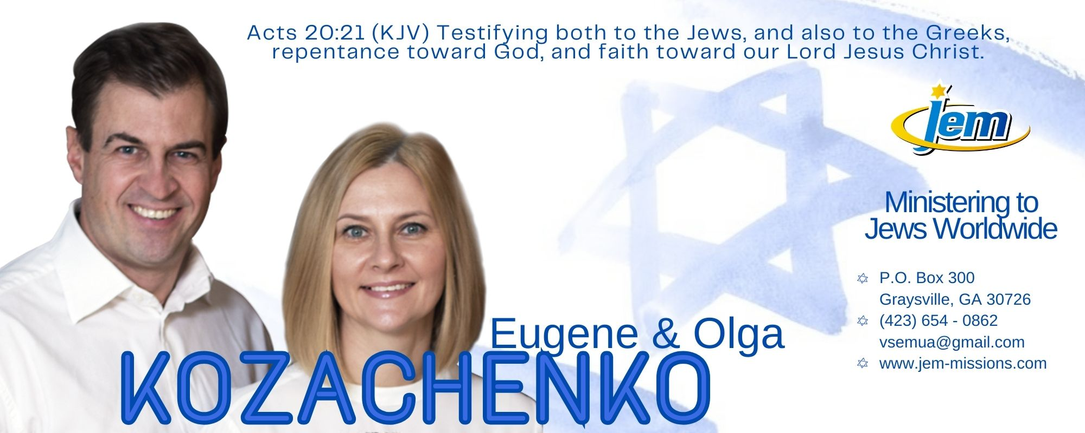

**APRIL-MAY-JUNE 2024**

My Dear Praying Friends,

Last time when we reported to our supporting churches was five years ago, in 2019, so as soon as we came to USA in April, we started our fifth official furlough accounting for the past years of ministry as well as informing of our ministry move. By the end of June, we would have already visited 25 of our churches and scheduled 70% of all the churches we have well into the month of October. I am yet to reach out to these states: NC, VA, OR, IA, MI, IL. We are hoping and praying to visit all our supporters by the year’s end. So grateful for Zoar Baptist church (Ironton, OH) allowing us to reside in the church’s parsonage so we are perfectly situated among most of our supporters in OH and WV and use the parsonage’s address for the proof of residency necessary to obtain all legal documents we are required to have. We already received SSNs, drivers’ licenses, work permits, established bank accounts and other – all in short three months’ time. We praise the Lord for a fast-paced establishing process and moving right along with our furlough!

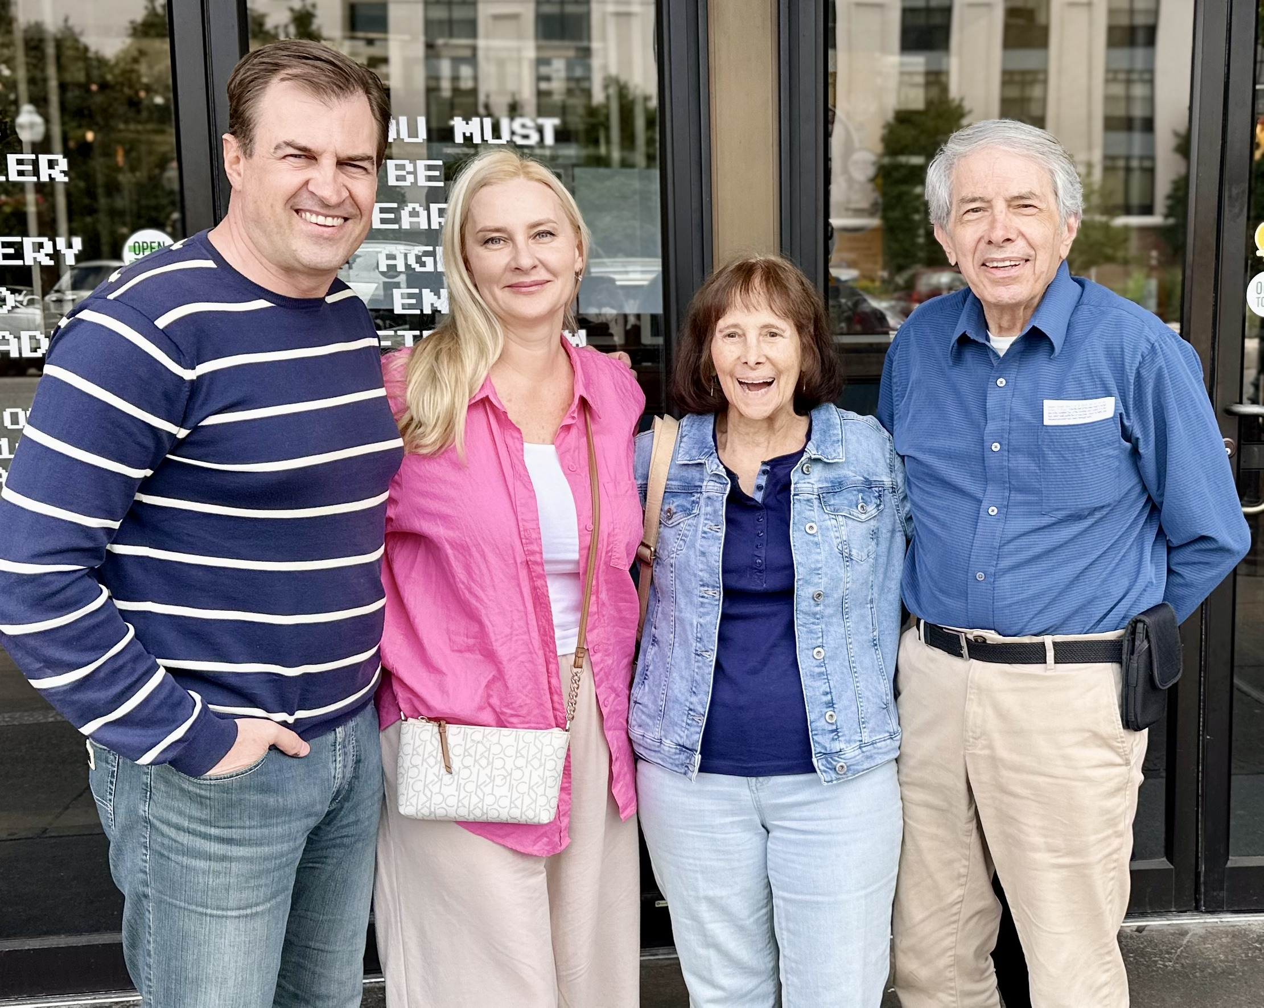In July and August we will travel west through TN, AL, MS, LA, AZ, CA visiting churches and spend the month of August in California in meetings there. Two of our children are heavily involved in Jewish ministry these summer months: Sophia in Los Angeles, CA (her second consecutive year doing it) and Evan in Philadelphia, PA (his first time) and we will pick them up just before their school year at West Coast Baptist College. Olga and I would like for them to take us several times while we are together to Jewish neighborhoods in LA going door-to-door witnessing (something they’d be very familiar with and we need to get accustomed to doing for our future ministry). Something I will talk about in greater detail in the upcoming prayer letters how we want to weekly reach out to Jewish communities to be in front of Jewish people sharing their Messiah with them in person. **Please, pray for both Olga and I, as well as for Sophia and Evan, as we leave the Word of God with God’s precious people – the Jews.**

One of our supporting pastors and his wife took Olga and I to meet this elderly Jewish couple in Huntington, WV, their friends of many years, Leonard and Judy. Wonderful people, educators, well-known in the community, in need of the personal knowledge of Yeshua HaMashiah (Jesus Christ). We had a refreshing and entertaining time getting to know them, inserting the words of witness in every conversation, leaving them with several pieces of Gospel literature (tracts) but most importantly having the door open to go back and spend more time with them (as Lenny promised to give us a personal guided tour of one of the museums in the area). **Please, pray with us for these dear Jewish people.**

Other Jewish ministry opportunities for us so far include multiple Christ in the Passover Seder Meal presentations (four) performed in churches for the congregations and unbelieving invited guests, special Jewish teachings in churches and supplying Jewish Gospel literature for those willing to give it out in bigger American cities.

Our son Nikita - our ministry partner, gives good reports of his ministry in Ukraine – Menorah Baptist church has joyfully taken him in as their new pastor and he tirelessly preaches and ministers there adding new aspects of ministry – refugee meetings, securing humanitarian aid for such meetings, door-to-door visitations in addition to gospel tracts street distributions, other. I am staying in a constant touch with him continuing the ministry in Ukraine. **Please, do pray for God’s blessings and protection from the war for Nikita Kozachenko and his work there.**

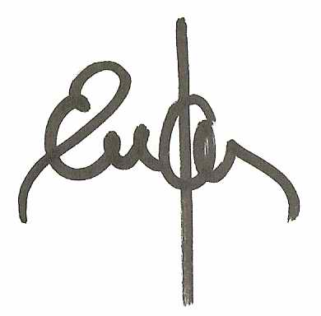Most of our churches display our prayer cards as missionaries to Ukraine, some even list us as church planters in Ukraine. And while we did plant churches and did minister in Ukraine for the past 25 years, I want to reinforce the fact that we are first and foremost, and always introduced and positioned ourselves as, missionaries to the Jews. Our ministry is more about the ‘who’ than about the ‘where’ so **we ask you to please pray for Olga and I as we make this transition between the two countries, get established, situated, and continue our Jewish ministry with renewed vision and zeal. Thank you for having us come visit you and we so look forward to seeing you in the upcoming months. God bless you richly!**

Your Ambassadors to the Jews,

Eugene and Olga

Acts 20:21