

Dear Praying Friends, **MORE GREAT BLESSINGS**

I never get tired of sharing with you the great blessings of our Evangelistic Outreaches into Cuba. I only wish that you could come there and see what the Lord is doing. Even in the midst of constant power outages, food shortages, and terrifically high fuel costs, **the Lord is working in the hearts of the Cuban people.**

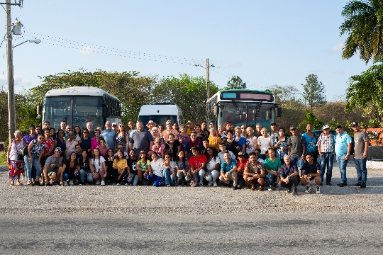This month we traveled to the city of Valutas in the center of the country. Along with our group of 9 Americans came 97 National Missionaries to help us go soul winning door to door. Every home had a ready heart to hear the Gospel of Christ who is their only hope in this depressed country. We worked in 6 different Churches, traveling by electric motorbikes, even horse and buggies. On Friday night at many of the Churches, the power was off and we preached by flashlights. On Saturday, Victoria held a large Baby Shower with more than 100 women present. After playing games, sharing gifts and taking pictures, Victoria spoke and then gave an invitation. **38 women made professions of faith in the Lord.**  Then in the afternoon, Jason Jordan held a children’s program with 325 kids present. More than 25 of them also professed Christ as their Savior. In nearly every home we went into, the people accepted the Lord. At the end of the Outreach, we had recorded 605 people who indicated they were trusting the Lord. Even though I report to you that many people are being saved in these Outreaches, I NEVER GET USED IT, AND WANT TO SEE MORE PEOPLE SAVED WHILE WE HAVE THE TIME.

This year we will be conducting a total of 7 Outreaches into Cuba. Would you consider doing two things for me.

1. **Would you consider going with us on one of our Mission trips.** The Cuban government gives us religious visa’s to be able to preach and speak in Churches. We also go out on the streets with National Missionaries to go to people home. It is very safe there and in all the nearly 20 years that I have been going there, we have never had any incidents. The people welcome us and are glad to have us share. Perhaps your Church would send a group to go with us. We have a trip planned for September and November. Come go with us.
2. **Please help us financially!** The cost of everything there has gone up dramatically. We have to rent buses to transport Missionaries, we house and feed them, bring in translators and there are many other expenses involved. Victoria and I purchase new baby clothes, baby bottles, blankets and a ton of other items to take to the women who have NOTHING! The cost of the clothes is around $700 per trip as well as airline tickets at $500 each. I am not complaining and am so thankful for everyone who had helped us in this ministry. We are need of at least $10,000 dollars to cover the cost of the remaining year.

So many have helped us over the years with the cost of working in Cuba, Ukraine, Philippines and a number of other countries and as a result we have seen thousands of people make professions of faith. Only eternity will tell what has been accomplished but the rewards are yours.

**UKRAINE**

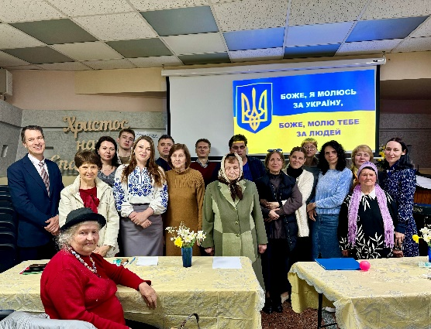I want to brag on my wife Victoria for a minute and let you know about her month-long trip to Ukraine that she just returned from. Victoria has been studying Biblical Counseling for nearly three years now, online in a Seminary in Ukraine. She really wanted to attend an actual session in the Seminary, so we planned on her going to Ukraine to visit. Before she went to the Seminary, she had the opportunity to travel to Kiev to visit some family members of people she knows. She made this special trip just to witness to these people. To the glory of God, Victoria was able to lead five people to the Lord during her trip. She was also able to spend time with her family who are still there. Recently, a missile exploded near her mother house and blew out all the windows. Thank the Lord everyone was ok. Please pray for Ukraine. We hope to be able to return there later this year.

Thank you for you continued support of our ministry. The Lord has opened the door for us to witness to several Jewish people recently and we continue to work with them. Pray especially for Sam whom I spend several hours with recently. God bless you for all you have done for us.

Henry and Victoria Benach