Missionaries Will and Stephanie Knox

Will’s Cell phone: (864) 504-2497

Email: [wknox@roapm.net](mailto:wknox@roapm.net)

**\*May & June Prayer Letter\***

**“To every thing there is a season, and a time to every purpose under the heaven” Eccl. 3:1**

Over the past few months, I have really hung on to the verse above. If I’m being honest, I was growing quite discouraged as nothing seemed to go as we had been hoping. Every turn was met with a closed door or another roadblock. One of my leaders within our ministry told me that “the Lord was taking me to school now.” Well, I hope I passed his class! It took until late June for the doors to begin to open for our ministry, but praise the Lord he has opened some doors. We have been seeking clearance to work in Kentucky, Missouri, and Tennessee; and until last week we had seen zero progress with any of these states. Tennessee is the first of the three to grant us clearance! I was able to drive down to my host facility in Tiptonville to get my facility badge and meet the Chaplain. He took me around the prison and told me of an immediate opportunity to hold services. Lord willing I’ll be starting next week on a monthly rotation in that facility! We also have several revivals scheduled in the next few months in Tennessee. I recently learned that we have a missionary up in Indiana who has need of someone to help him. He in trying to cover 5 states with only himself and one other man. To make things worse, the other brother recently had 2 strokes and he is unable to do anything. Please pray for his recovery. I have submitted the paperwork for Indiana and I will be going to take a required training in a couple of weeks. If everything goes well, Ill be helping him as often as I can. I mentioned in my last prayer letter that the prisons in southern Illinois were on my heart. After speaking to our brother in Indiana, he told me that in a couple weeks he will help me lay the ground work to get into those prisons. He currently has access to one of them himself. It’s amazing watching the Lord put pieces together in his perfect timing! Also we are having a training this month so I can begin serving in the local county jail. Things are really coming together and we have gotten to the place where my schedule is full almost every week from now until middle of November! It feels good getting back into prison! In the month of August I will be going to Texas for 2 weeks to help one of our coordinators work a couple prisons out there as well. With all of this traveling and lodging I have some extra financial needs and our current support level won’t cover them all. Anything extra would be greatly appreciated! We love each and every one of you!

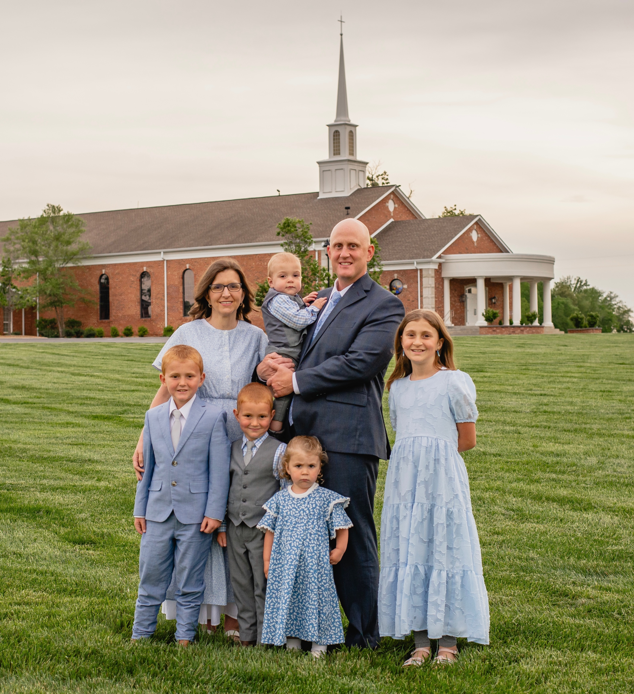

**We are so thankful for your prayers and financial support!**

Your Missionaries to the Prisons, The Knox Family