

The Knox Family - Missionaries to the Prisons – 322 Chevy Chase Blvd, Pelzer SC 29669
Will’s Cell: 864-504-2497
wknox@roapm.net
*March and April Prayer Letter*
“…and let us run with patience the race that is set before us, Looking unto Jesus the author and finisher of our faith…” Hebrews 12:2
Let me start by thanking everyone who has taken the time to pray for us! The Lord has added his blessing and favor to our deputation as we currently sit between 30-35% of our support! The journey has had its moments of exhaustion, but it has truly been exciting watching the Lord provide. Please help us pray that the Lord will supply at least 5% per month of new support. He put this number in my heart one morning in prayer. Our desire is to be finished with our deputation by June of next year and we are on track for that. We welcomed our fifth child, Samuel Levi, on March 25, 2024. He was 9lbs 15 ounces, which is our second biggest child. His brother Andrew was a whopping 10lbs! Mom and baby are healthy, and we thank the Lord that all of our children have been healthy. Our schedule with deputation is very busy! Mostly it has just been my two oldest children and myself traveling. I am currently booked through the end of October with only around a dozen more dates to fill between now and then! We thank the Lord for the good reception we have had while contacting pastors. With all the traveling for deputation it doesn’t leave much time to work the prisons yet, but we have managed to keep our goal of one prison revival each month. We were able to work in Kirkland Correctional Institute in the month of March and the Lord saved 5 men by his grace! We were able to sow much seed and the response was good, we just need to pray that those seeds will begin to grow. This past week we were able to get into a prison which is only ten minutes from my house! The name of the prison is Perry Correctional Institute. Our ministry has not been able to work this prison in over ten years, so we praise the Lord for the open door he has reestablished with this prison! Over 3 days we saw 8 men come to know the Lord Jesus Christ! Several more were under conviction but just not willing to surrender to the grace of God yet. Please pray for these men. On our first day we had one respond to the preaching and boy did he respond! He was weeping and so broken over his life of sin. He made many references to how he needs to be the kind of father that his children need and lead them in the ways of the Lord! The next day at service he came to me and told me this, “I feel so light inside! It feels like something has changed inside of me, all the burden I had has been lifted!” On the last day, we visited his dormitory, and he was studying his King James Bible! I was able to talk with him and he did something incredible. He opened his Bible and showed me some scriptures that the Lord had used to convict him about what he did to get put in prison. Praise the Lord for genuine conversion! He is going to enroll in our Prisoner Bible Institute. Please pray for him.
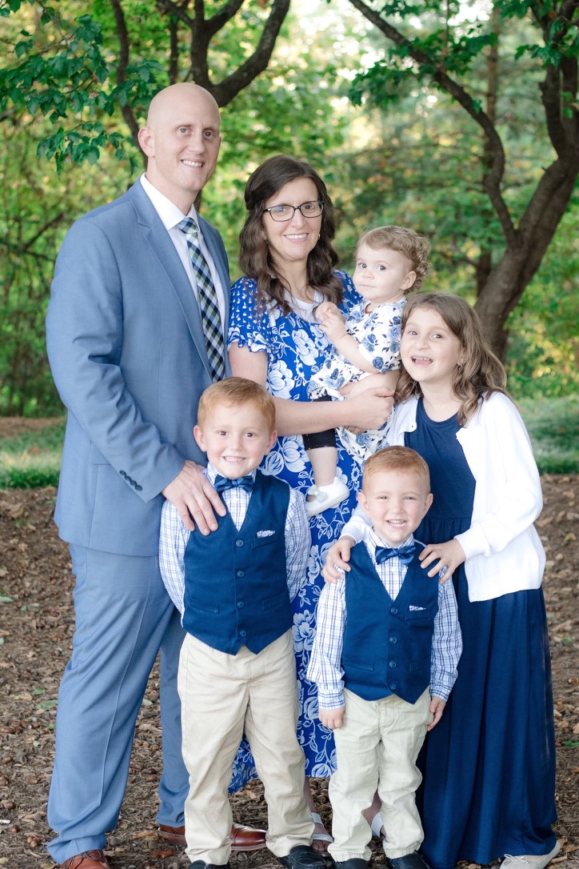

We are so thankful for your prayers and financial support!

Your Missionaries to the Prisons,
The Knox Family

